

Lab Session 04(B)

***(SubQueries)***



# SubQuery:

In SQL a Subquery can be simply defined as a query within another query. In other words we can say that a Subquery is a query that is embedded in WHERE clause of another SQL query.

### Why use subqueries?

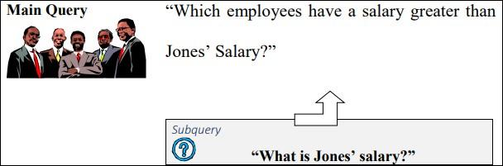

The inner query or the subquery returns a value that is used by the outer query or the main query. Using a subquery is equivalent to performing two sequential queries and using the result of the first query as the search value in the second query.

The subquery can be placed in a number of SQL clauses:

* WHERE clause
* HAVING clause
* FROM clause

The syntax of SELECT statement using subqueries is

*SELECT select_list FROM table*

*WHERE expr operator*

*(SELECT select_list FROM table);*

**Note:** In the syntax, operator means comparison operator. Comparison operators fall into two clauses: single-row operators (>, =, >=, <>, <=) and multiple-row operators (IN, ANY, ALL).

**For example**, to display the names of all employees who earn more than employee with number 7566.

***SELECT ename FROM emp WHERE sal > (SELECT sal FROM emp WHERE empno = 7566);***

**Types of Sub queries**

**Single-row subquery:** Query that returns only one row from the inner SELECT statement.



**Multiple-row subquery:** Query that returns more than one row form the inner SELECT statement. **Multiple-column subquery:** Query that returns more than one column from the inner SELECT statement.

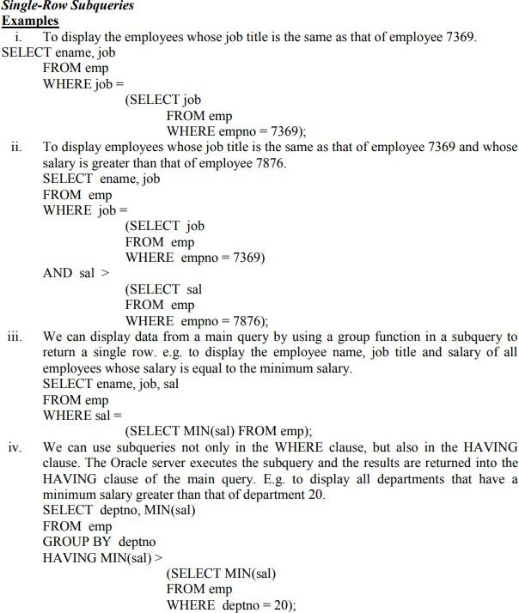



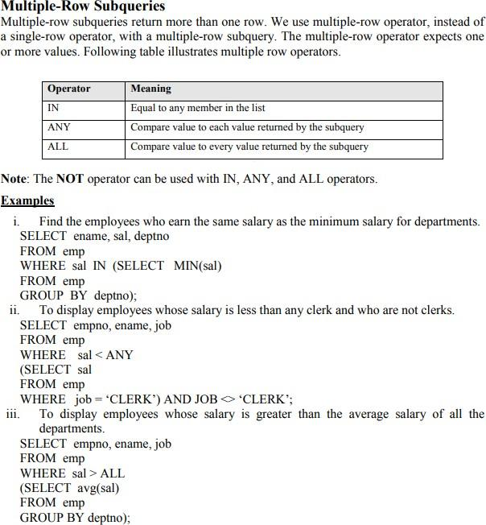

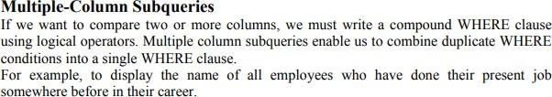



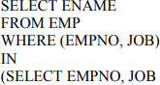

C:\Users\ammara.yaseen\Desktop\Capture.PNG

**Exercise**

* + 1. Write a query to list the name, job name, department name, salary, and grade of the employees according to the department in ascending order.
    2. Write a query to list the department name where at least two employees are working.
    3. Fetch all the records where salary of employee is less than the lower salary.
    4. List department number, Department name for all the departments in which there are no employees in the department.
    5. Display employee name, salary, department name where all employees has matching department as well as employee does not have any departments. This query should include non-matching rows.
    6. List employee name, salary, department name of all employees whose salary is not within the salary grade 04.
    7. Write a query to list the name, job name, annual salary, department id, department name and grade of the employees who earn 60000 in a year or not working as an ANALYST.
    8. Write a query to list the employees who are senior to their own manager.
    9. List employee name, salary, department name of all employees whose salary is within the salary grade 02.
    10. Write a query to list the name, job name, department, salary, and grade of the employees according to the department in ascending order.
    11. List all those employees who are working in the same department as their manager (Sub query)



* + 1. Retrieve all employees who are working in department 10 and who earn at least as much as any (i.e. at least one) employee working in department 30.
    2. List all employees who are not working in department 30 and who earn more than all employees working in department 30.
    3. List all department that have no employee.
    4. Write a query to display the name, department number, and salary of any employee whose department number and salary match the department number and salary of any employee who earns a commission.
    5. List the job title and total monthly salary for each job except SALES, with a total payroll exceeding $5000. Order the output in descending order of sum of salaries.
    6. To display all the employee’s name (including KING who has no manager) and

their manager name.

* + 1. Create a unique listing of all jobs that in department 30. Include the location of department 30 in the Output.
    2. Display the employee name and employee number along with their manager’s name Manager Number. Label the columns Employee, Emp# , Manager, and Manager#, respectively.
    3. Find the employee name who earn second highest salary.